**Kindly review the images in** [**https://webdmzqa2.centurylink.com/**](https://webdmzqa2.centurylink.com/) **. Mobile nav and footer WIP a still…**

1.For making the residential section 720px tall, image resolution of 680X720 is required. The one that is provided is too wide(960X720) and scaling it appears as shown below.

2.Adding 94px space to the left of Residential content section, shifts the text (“access”) to the next line because the total width of the container is 90% only. Hope that is fine?

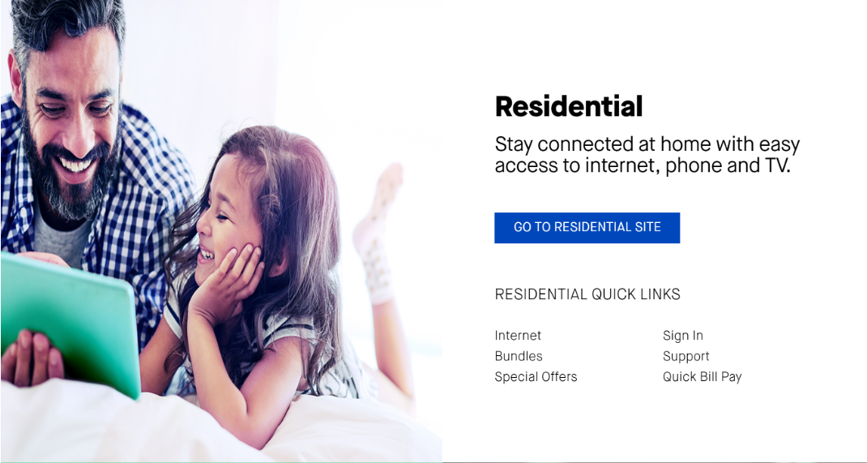

3.In small business blade, image size of 660X720 is required. Scaling the given asset appears as shown below.

4.What should be the href for internet and voice?



5. In the footer section, adding 24px spacing in between the social media icon with the given image size is not possible because the total width is only 90% on the screen size. I have scaled down the images so that there is some clearance between them.



6. For mobile, the font-size is supposed to be extra bold as in desktop?

